Security Standards for Dialogflow CX
(Living Document)
Introduction
This document outlines the Google best practices and security standards required for the deployment of Dialogflow CX and Agent Studio. These standards are to be used in your GCP infrastructure in general and should be extended to this AI feature. This ensures a baseline for a robust security posture by balancing preventative controls during resource provisioning with continuous detective monitoring in production environments.
Contents
1. Strategy Overview 1
2. Identity & Access Management (IAM) 1
3. Network Security & Webhook Protection 2
4. Data Protection & Encryption (CMEK) 2
5. VPC Service Controls (VPC-SC) 3
6. Automated Governance (Checkov & CI/CD) 3
7. Detective Controls (Monitoring & Alerting) 4
8. Infrastructure as Code (Terraform) 4
9. Console Implementation Steps for Testing 5
10. Advanced Monitoring & Analysis Tools 6

1. Strategy Overview
Google best practices recommend a multi-layered defense strategy for managed conversational AI services.
- Preventative Controls: Proactive measures designed to stop unauthorized actions before they occur, such as Least-Privilege IAM, mTLS for webhooks, and CMEK encryption.
- Detective Controls: Continuous visibility through Cloud Monitoring/Logging, DLP scanning, Policy Analyzer and Security Command Center (SCC) findings to identify and remediate security drift. Enabling Alerts for events that exceed defined thresholds.

2. Identity & Access Management (IAM)
Overview:
Access must be restricted to the minimum permissions necessary, specifically avoiding primitive roles (editor/owner).
Standards:
- Role Segregation: Distinct roles for Agent Builders, Webhook Developers, and CI/CD Automation.
- Group-Based Access: All permissions must be enforced via group-level assignments rather than individual user accounts.
- IAM Recommender: Uses ML to suggest least‑privilege permissions.

3. Network Security & Webhook Protection
Overview:
Webhook traffic must stay within private, authenticated channels to prevent data exfiltration.
Standards:
- Private Connectivity: Use Private Service Connect (PSC) or Internal Load Balancers; public endpoints are prohibited.
- mTLS Enforcement: Mutual TLS (mTLS) is required for all webhook calls to ensure certificate-based authentication.
- Cloud Armor: Used to protect external APIs and webhooks.

4. Data Protection & Encryption (Google Managed vs CMEK)
Overview:
Google’s Key service encrypts data at rest. You have the option to use Google Managed Keys or Customer-Managed Encryption Keys (CMEK).
- Google managed keys (AES‑256) have low operational overhead and should be used for simple encryption of data that does not need to meet compliance standards.
- CMEK should be implemented for workloads handling sensitive data (PII) to maintain cryptographic control.
Standards:
- Location-Level Encryption: CMEK must be initialized for the specific Google Cloud region before agent deployment.
- DLP Scanning: Utilize Data Loss Prevention (DLP) to scan training phrases and agent exports for sensitive data. DLP detects sensitive information in text, images, and structured data, and can transform or mask it to reduce exposure risk.
5. Secrets Manager
Overview:
Securely stores API keys, passwords, tokens.
Standards:
- Create Secret in Console, CLI or Terraform
- Grant Access to secret via IAM binding to Service Account (Workload)
- Access Secret in Runtime through mounting(simple) or API call
- Enable rotation (every 90 days)

6. VPC Service Controls (VPC-SC)
Overview:
A service perimeter is established at the Organization level to mitigate the risk of data exfiltration. While the perimeter is an Org-level resource, it protects specific Projects.
Implementation Steps (Console):
- Navigate to Security > VPC Service Controls: Click "New Perimeter."
- Select Projects: Add the projects containing Dialogflow CX.
- Restricted Services: Add dialogflow.googleapis.com to the perimeter.
- Ingress/Egress Rules: Define explicit rules to allow authorized outside APIs to interact with services inside the perimeter.

7. Automated Governance (Checkov & CI/CD)
Overview:
We utilize automated policy-as-code scanning to validate infrastructure code during the CI/CD process, preventing non-compliant resources from being deployed.
Technical Detail:
The following is a sample of some Checkov policies that can be enforced as our security baseline:
- DF001: Enforces mTLS for all webhook configurations.
- DF002 / DF003: Prohibits plaintext secrets and mandates Secret Manager for GitHub tokens.
- DF005: Validates that Webhook URIs are not public (enforcing PSC or Internal LBs).
- DF006: Ensures IAM roles do not include broad Editor or Owner permissions.
- DF007: Prevents the deployment of production-labeled agents into Sandbox projects.

8. Detective Controls (Monitoring & Alerting)
Overview:
To maintain operational integrity, we will extend the current project’s monitoring and alerting suite to include Dialogflow-specific telemetry.
Logging & Audit Trails:
We will enable and monitor the following logs to maintain a full audit trail:
- Cloud Audit Logs: Tracking Admin and Data Access.
- Dialogflow Interaction & Webhook Access Logs: Monitoring agent behavior and endpoint connectivity.
- Security Logs: Tracking Certificate usage and GitHub audit logs.
Alerting Standards:
Critical alerts will be configured for:
- Security Events: Unauthorized IAM changes, API enablement attempts, and suspicious certificate usage.
- Operational Health: Webhook failures, high error rates in detectIntent, and webhook timeouts.
- Behavioral Anomalies: Unexpected agent exports/imports, excessive modifications, or abnormal traffic patterns.

9. Infrastructure as Code (Terraform)
CMEK for Dialogflow CX is a per-location setting initialized at the project level. It is not currently a native argument within the google_dialogflow_cx_agent resource.
Dialogflow CX Agent Sample Code Snippet:
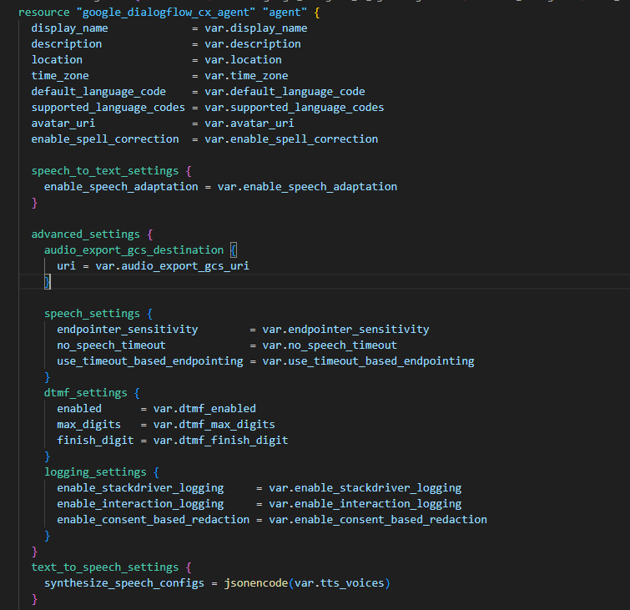}

10. Console Implementation Steps for Testing
- CMEK Initialization: In KMS, grant the Dialogflow Service Agent (service-<project-number>@gcp-sa-dialogflow.iam.gserviceaccount.com) the Cloud KMS CryptoKey Encrypter/Decrypter role.
- Location Settings: In the Dialogflow CX console, navigate to Settings > Location and select the managed KMS key.
- Webhook Validation: In Manage > Webhooks, toggle Enable Client Certificate to validate the mTLS handshake.

11. Advanced Monitoring & Analysis Tools
- Policy Analyzer: Provides visibility into complex IAM hierarchies to identify over-privileged identities.
- Security Command Center (SCC) Premium: Offers continuous threat detection and identifies misconfigurations in real-time.
  - Pricing for SCC Premium

